***Predictive Model:Deepfake Detection***

*Authors :* ARCHANA P: [parchanaai@svecw.edu.in](mailto:parchanaai@svecw.edu.in), VENKATA KUSUMA LATHA CH : [chitikireddykusuma328@gmail.com](mailto:chitikireddykusuma328@gmail.com), MYDHILI D: [mydhilidhulipalla07@gmail.com](mailto:mailtomydhilidhulipalla07@gmail.com)ANU P: [anubudithe19@gmail.com](mailto:anubudithe19@gmail.com) , PUJITHA J: [21b01a5445@gmail.com](mailto:21b01a5445@gmail.com),

# ***Abstract***

The evolution of AI, machine learning, and deep learning over the last few decades has changed the world’s approach to multimedia several times. The advancements however, have been a bane as well as a boon since they helped the creation of high quality realistic fake videos, audios and images which have extended the possibilities of spreading misinformation, inviting numerous political conflicts, and even defaming individuals. These marks of altered synthetic video footage are referred to as Deepfakes. In order to provide a more recent picture of research efforts to combat the creation of Deepfakes through the detection of such content , the authors of the paper under review rewrote quite a number of facts around the issue of deepfakes from 2018 to 2020 covering about 112 articles which formed the body of their research. The authors closely examined the articles and divided them into four groups: deep learning-based, classical machine learning based, statistical and blockchain based approaches. Three of the many deep learning encoding-decoding techniques were tested, and the evaluation focused on the detection accuracy on various datasets, eloquently concluding that deep learning based approaches provided the best results in the detection of deepfakes. This research adds to our body of knowledge by presenting an elaborate structured survey on deepfake detection, proposing a new classification of deepfake detection techniques and tools, examining and detailing the adequacy of reported evidence concerning a range of reported phenomena singularly, and making some predictions and suggestions.

**Index Terms**: Deepfake detection[2], Video or image manipulation[[3],](https://edit.paperpal.com/chat-pdf?_gl=1%2Amirzv3%2A_gcl_au%2ANjM1OTU0MDk0LjE3MzQ3OTY3NzQ.%2A_ga%2AODAzNTAzNjI4LjE3MzQ3OTY3NzU.%2A_ga_FX8NVDLJ9Z%2AMTczNDc5Njc3NS4xLjEuMTczNDc5Njg1NS41OC4wLjA) Digital media forensics[4], Systematic literature review[5]

**INTRODUCTION:**

With the rapid advancement of artificial intelligence (AI) and deep learning, the generation of highly realistic synthetic media, commonly known as **deepfakes**, has become a growing concern. Deepfake technology leverages AI-driven techniques, particularly **Generative Adversarial Networks (GANs)** and **autoencoders**, to manipulate or fabricate visual and audio content, making it nearly indistinguishable from real media. While deepfakes have potential applications in entertainment, education, and digital media, they also pose significant threats, including misinformation, identity fraud, and the erosion of public trust.

To counteract these challenges, **deepfake detection** has emerged as a crucial research area in computer vision and artificial intelligence. The goal of deepfake detection is to develop **automated and efficient models** capable of distinguishing real content from AI-generated manipulations.

These tools have an option to manipulate the facial structure and more features like hairstyle along with altering the age and gender. In this day and age, with the advent of years of progress across all domains, it makes me want to ponder: doesn’t these ‘Deepfake’ videos rattle you? I mean it is horrifying to see the computed visuals given how frowned upon these videos are, and honestly how comically ironic the name is “Deepfake” where the term combined consists of Deep Learning and Fake. The name, its claimed had originated from a Reddit user and with it came the innovation that allowed user to create 3D videos featuring unknown impersonitators in pornographic video.

But the issue with combining these terms is their unethical use, just like creating altered political faces, insuring terrorism, and using it for all the mentioned purposes. Now what are the best options to tackle this problem in the upcoming future, deepfake detection, and history shows that their relationship has always been good, so looking back to the last few years the field of deepfake detection has significantly evolved.

**PROCESS OF SLR:**

Systematic Literature Review (SLR) on Deepfake Detection

This paper critically analyzes the activity of Systematic Literature Review (SLR), beginning with its definition and proceeding through its two key steps: Planning the Review and Conducting the Review.

Planning the Review

This stage consists of:

* Articulating the justification for undertaking the SLR on deepfake detection research.
* Conducting the first stage analysis based on pre-established criteria and procedures to ensure readiness for the planning stage analysis.

Conducting the Review

This stage includes six obligatory phases:

Research Questions (RQs)  
The use of meta-analysis answers in terms of geography and economics a set of research questions (RQ1-RQ5) prepared by the authors for the process of literature review on deepfake detection-related studies.

Search Strategy (SS)  
A nonpartisan search strategy is developed by the authors to discover the maximum number of fundamental research papers within ten large electronic databases.

Study Selection Criteria (SSC)  
The authors establish criteria for inclusion and exclusion to determine the most appropriate studies for review.

Quality Assessment Criteria (QAC)  
The authors classify the papers into sets of covariates, forming various criteria to capture all relevant information related to the quality of the reviewed studies.

Data Extraction and Monitoring (DEM)  
A structured approach is designed to extract all relevant pieces of information from the selected studies and determine the appropriate pieces of evidence to be cited.

Data Synthesis (DS)  
Specific procedures are followed for correlation and assessment of the results obtained from the reviewed studies.

After completing the review, the authors present the findings in an appropriate format for distribution to the target audience.

**Methodology:**

Descriptions of Study

This systematic review captures 112 studies published within a time span of 2018 and 2020, probably reflecting how busy research is booming with regard to the detection of deepfakes. The number of publications thus grew within a short time and highlighted some urgency and interest to tackle problem areas on deepfake. Most studies were commonly from workshop/conference proceedings and journals, with a big number coming from archives, such as arXiv[8] rather than original works.

Popular Deepfake Detection Techniques

Here are the main four categories for compiling detection techniques,

**Deep Learning Based Techniques**:

This was the most popular category covering 77 percent of the studies. Modeling techniques mentioned included Convolutional Neural Networks (CNN), Recurrent Neural Networks (RNN), and ensemble-learning models having clearer detection accuracy.

**Machine Learning-Based Techniques**:

These accounted for 18 percent of the studies and were based on the crafted feature extractions which included visual artifacts as well as facial landmarks.

**Statistical Techniques**:

These comprised 3 percent of the studies and applied measures such as correlation of scores and PRNU analysis.

**Blockchain Based Techniques:**

This accounted for only 2 percent of the studies where the technology decentralized verification of documents.

**Datasets Applied in Detection Studies:**

The Deepfake dataset by PeilWang is designed for deepfake detection research. It consists of nearly 25GB of images, divided into a training set containing real and fake images and a validation set for model evaluation. CSV files are provided to map image filenames to their corresponding labels, where 0 represents a real image and 1 represents a fake image.

These studies demonstrated various datasets strategic in research on Deepfake detection, where FaceForensics++, Celeb-DF, and the Deepfake Detection Challenge (DFDC) are considered most commonly used. These datasets serve as benchmarks for testing detection algorithms since their current diversity presents challenging and slightly biased.

Features Used for Detection: A particular set of features is employed by detection techniques for differentiating the manipulated content from the original ones. Types of Special Objects Generated by Manipulations in Contents: Generalized-Logits and Aberrations are such categories. Spatio-Temporal Consistency: Accord between frames. Biological Signals and Face Landmarks: Also blinks and heartbeats. Features on the basis of GAN: Among latent patterns discerned by generative adversaries, there is. Models of Detection: In general, deep learning models outshine traditional approaches. CNNs and RNNs (including hybrids) can count among the highest performers when it comes to high accuracy. Other methods in the machine learning realm include Temporal support vector machines, Ramirezs Random Forests, and other statistical methods including expectation maximization and hypothesis testing to add some insights into the situation. Metrics Used for Evaluating Models: Accuracy and Area under the curve have been increasingly popular as performance measures. Other common metrics include precision, recall, and F1 scores for assessing performance. On this basis, detailed confusion matrices are obtained of true positive, true negative, false positive, and false negative rates.

Deep-learning detection mechanisms for Deepfake videos might, therefore, represent the end. Prediction accuracies predictive for deep learning is indeed discovered to be -89.73%, while the score of AUC was reckoned at .917. More so, these models happen to be the most formidable. Hence, machine learning models coupled with statistical techniques reveal very poor accuracy especially as applied to the new data set.

Fig 1:Precprocessing Image

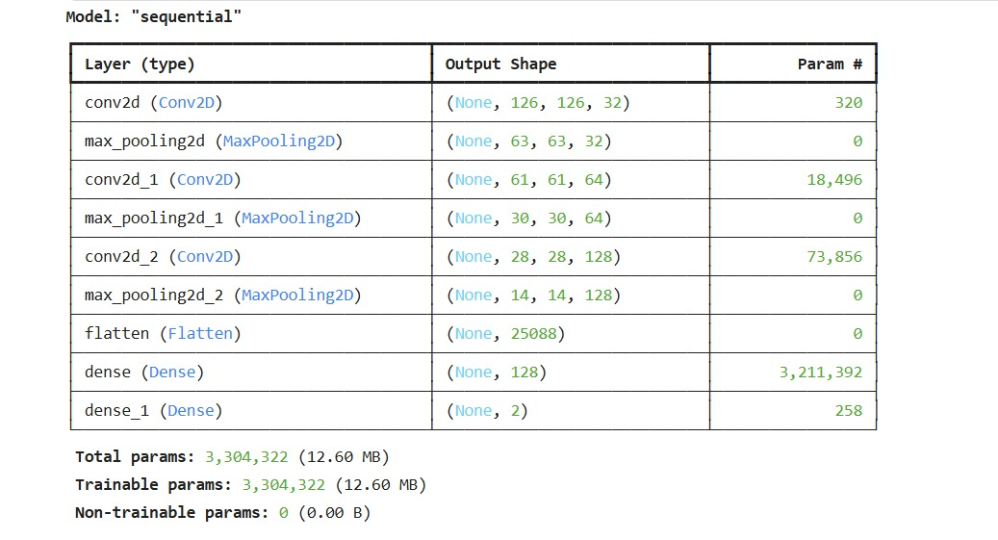

Fig 2:Graph Representation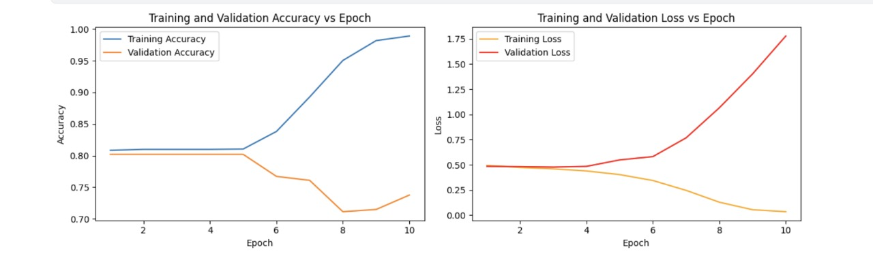

**Deepfake classification:**

It classifies the deep fake detection techniques based on input data that could be images, videos, or both; features being actively used, such as texture, landmarks, etc.; and detection method such as deep learning, machine learning, statistical, and blockchain. As per the taxonomy, deep learning techniques exploited face manipulation incorporated in Deepfake, while other statistical and machine learning approaches used digital media forensics.

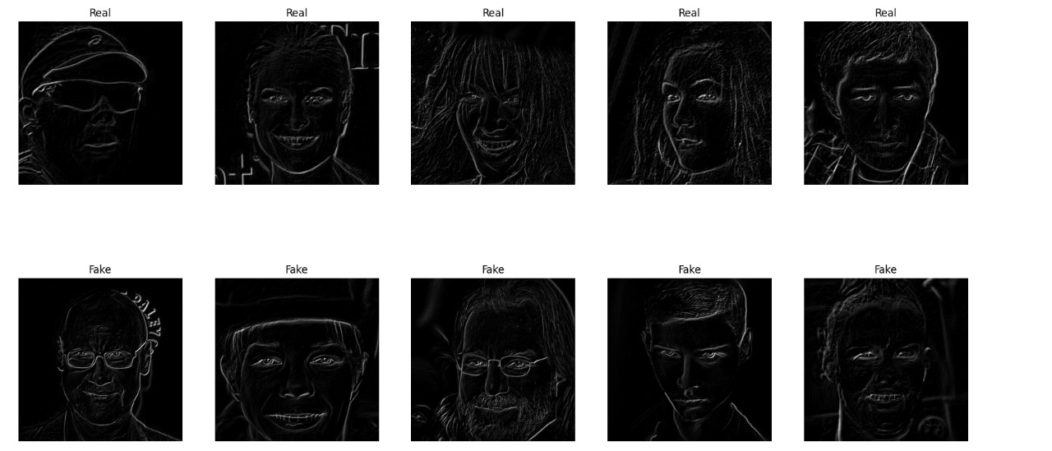

Fig 3: classification of fake and real faces

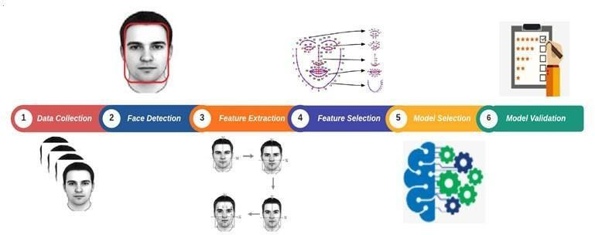

Fig 4: Steps of Deepfake detection

**OBSERVATIONS:**

The Leading Approach:

Deep Learning:

This review shows that deep learning-based approaches tend to dominate this field of Deepfake detection, as they offer much greater accuracy and generalizability than traditional approaches. Techniques that use convolutional neural networks (CNNs), recurrent neural networks (RNNs), and ensemble learning strategies emerged as the most effective. These models are capable of detecting slight but important inconsistencies in manipulated content, thus making them very reliable for addressing the challenges posed by fakes.

.Fig 5: List of Datasets used in Deepfake related studies

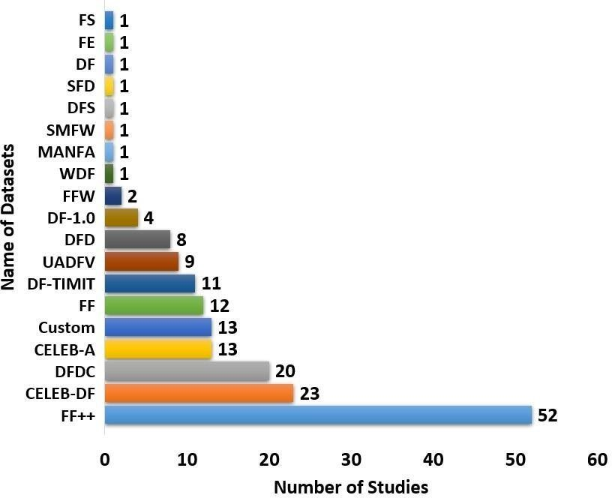

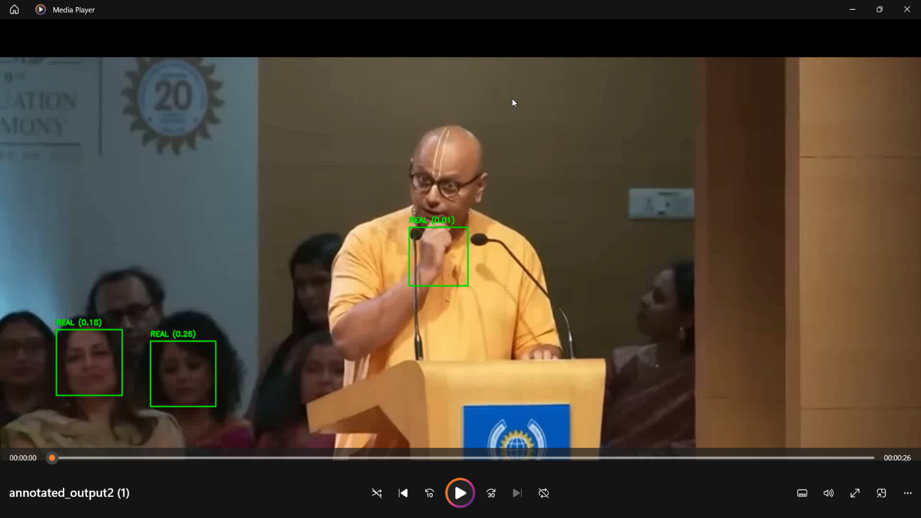

Fig 6:Detecting Faces

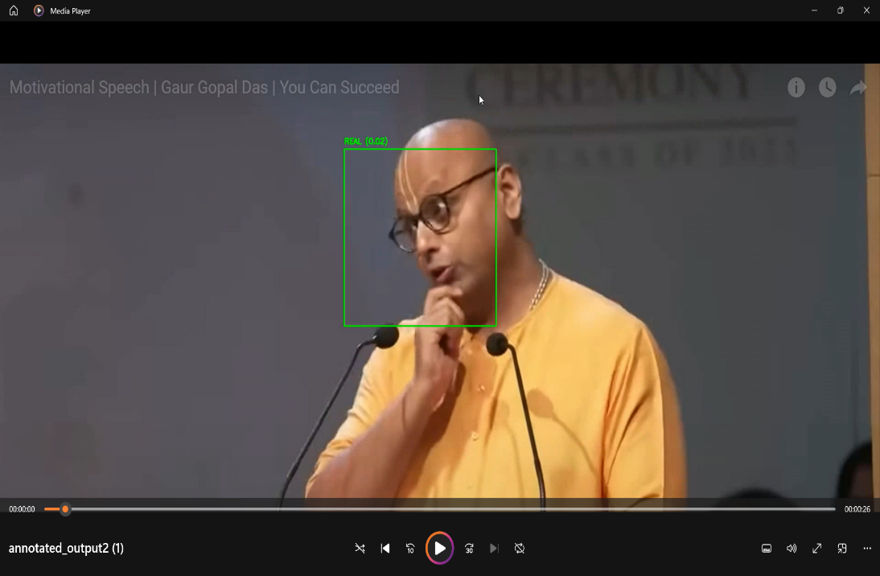

Fig 7:Detecting Faces

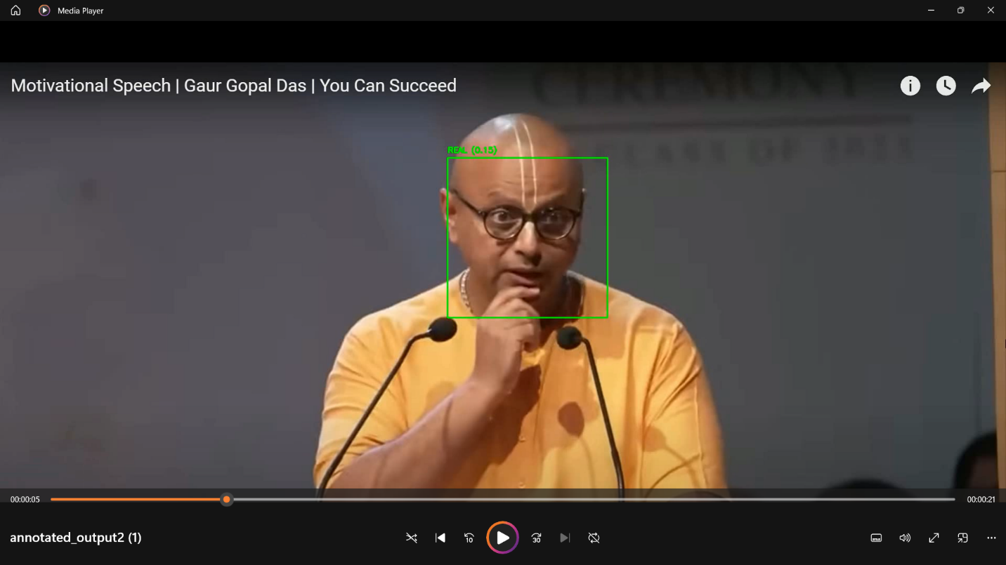

Fig 8:Detecting Faces

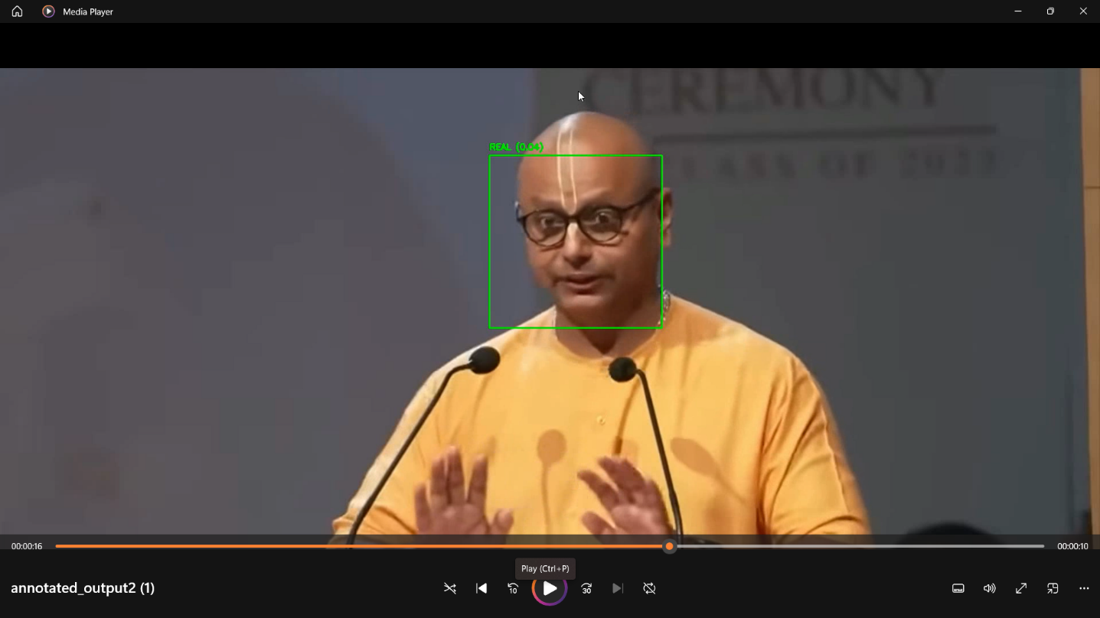

Fig 9:Detecting Faces

The bar chart also shows the frequency of studies using different datasets for deepfake detection. The most commonly used dataset is FaceForensics++, which has 52 studies, followed by Celeb-DF with 23 studies and DFDC with 20. The usage of small datasets, such as FS, FE, or DF, is minimal, indicating that bigger, more standardized datasets are favored for solid model evaluation.

Wouldn't it be amazing if they also brainwashed us like that? Why not teach them anything? That is precisely the technique they follow to train you.

The bar chart illustrates the frequency of studies using different datasets for deepfake detection. The FaceForensics++ (FF++) dataset comes first with 52, then Celeb-DF and DFDC with 23 and 20 studies, respectively. The use of small datasets like FS, FE, and DF is very limited, showing the preference for larger standardized datasets when it comes to robust evaluation of models.

**Combination of multiple deep learning methods:**

It's observation to note the effectiveness by combining different deep-learning approaches. The ensemble techniques, like DeepfakeStack, emphasize the fusion of classifiers to achieve a higher level of accuracy on the detection. Elseways, the hybrid techniques that include both spatial and temporal feature analysis give out more findings than those relying on a single method. Findings also point to the fact that complementary ways need to be used to counter the advanced techniques applied in rendering DeepFakes.

**Dataset Diversity and Generalization Challenges:**

But it became apparent from the studies that datasets that are strictly confined in scope and variously diversified for Deepfake detection, like FaceForensics++[9] and Celeb-DF, constitute a challenge to the application of detection models for generalization in the real world. Since these datasets are normally limited to controlled experimental conditions, this essentially negates the possibility of generalization to real-life scenarios. This void presents a challenge to designing reliable detection systems that would be able to scale with increasing demands of the real world.

**Unification of Evaluation Frameworks:**

One important gap identified in this review was the lack of a common platform for evaluation of detection methods, since differences in datasets, evaluation metrics, and experimental set-ups of the studies result in non-comparable performance reports. Towards this, it may be necessary that this study advocate for the establishment of standardized evaluation protocols for fairness and reliability in assessments through which detection models undergo evaluation.

**Emerging Anew in Blockchain Occupations:**

There have only been a few studies that have taken up blockchain-based methods [10] into consideration, but their contribution to an improved detection system is very promising. Blockchain provides decentralized as well as tampered-proof mechanisms to make sure of the authenticity and provenance of digital content. This review brings this point as an area that could be enriched with further explorations, especially with the integration of blockchain to already established machine learning and deep learning methodologies.

**Future Directions:**

Finally, the considerations note the necessity of innovation to cater to the continuous challenges, that is, overfitting, adapting methods of Deepfake generation, and talking about the need for real time detection. Integration of diversified approaches and collaborative effort among the research community will avert the impending threats gradually increasing in terms of Deepfake technology.

# **LIMITATIONS AND CHALLENGES:**

**Internal Validity:**

These data extractions and many analyses would prove troublesome retrieving. The amount of analyzed information being huge requires working safely on cross-checked and validated outputs so that they are accurate. Minor possibilities still lie for inconsistencies or wrong interpretations regarding outcomes produced by data collection and analysis.

**External Validity:**

The issue with the experiment is that one finds inconsistency across experiments set up in the studies reviewed, so it limits the findability of the results. The size, diversity, and evaluation metrics of the datasets usually cause difficulties in reaching concrete results between them. For instance, while some studies used the complete FaceForensics++ dataset, others used smaller subsets, leading to unequal performance. These variations lead to reduction in the strength of comparability and robustness of results reported.

**Dataset and Evaluation Constraints:**

Most of the existing datasets used for Deepfake detection, such as FaceForensics++ or Celeb-DF, lack diversity and have controlled cases, factors that prevent the detection model from generalizing well against real-life applications. In addition, one more factor impedes further comparison of methods: a lack of a uniform evaluation standard.

**Problems of Overfitting and Generalization:**

Deep learning methods, while often greatly useful, are often subject to overfitting problems when trained on small or biased datasets, which limits their ability to generalize over unseen or

varied datasets. While such applications of research address this need, more diverse datasets and robust model designs would be required to ensure scalability and adaptability

**Rapid Equipment of Deepfake Techniques:**

The domain of detection models. As in the birth of new techniques, the life cycles of existing detection models are shortened; therefore constant updates and improvements are necessary.

**Future Opportunities**:

It's true there are still challenges, but the review has found opportunities for new ideas, like the involved use of blockchain technology for content authentication and standardized evaluation protocols. It will take such a great effort for the research community to develop more robust, scalable, and reliable Deepfake detection systems to overcome these limitations and challenges.

# **CONCLUSION:**

A systematic literature review focuses on state-of-the-art detection techniques for Deep Fakes with a critical analysis of their developments in the area of further unexplored domains. The review analyzed 112 published articles of relevant literature dated from 2018 to 2020 and distinguished four types of methods- deep learning-based, machine learning-based, statistical, and blockchain-based detection methods. Results pointed to the fact that deep learning methods, especially Convolutional neural networks CNNs [12], dominate this subject area, mainly gaining a significant advantage in accuracy and endurance in cross-dataset comparisons. The readers will find FFS++ and Celeb-DF[13] to have played a considerable role in the development of detection techniques but whose limitations in terms of diversity and scope make it a challenge for field application. Besides generalization, the review also considers the importance of using several techniques for enhanced detection functionality. It further indicates that there is a need for a standardized evaluation framework for comparative effectiveness assessment, fairness, and consistency in evaluations running studies. Even though many things are realized, a lot of work has still to be done, especially on overfitting problems, dataset bias, and a constant new trend in Deepfake production techniques. Emerging technologies, including blockchain for content authentication, hold much promise for future research. The study provides insights into deepfake detection systems, which will be resourceful for researchers and practitioners in developing efficient, scalable, and robust detection systems owing to increasing threats from such technology.

# REFERENCES:

1. FaceApp. Accessed: Jan. 4, 2021. [Online]. Available: https://[www.](http://www/) faceapp.com/
2. FakeApp. Accessed: Jan. 4, 2021. [Online]. Available: https://[www.](http://www/) fakeapp.org/
3. G. Oberoi. Exploring DeepFakes. Accessed: Jan. 4, 2021. [Online]. Available: https://goberoi.com/exploring-deepfakes-20c9947c22d9
4. J. Hui. How Deep Learning Fakes Videos (Deepfake) and How to Detect it. Accessed: Jan. 4, 2021. [Online]. Available: https://medium. com/how-deep-

learning-fakes-videos-deepfakes-and-how-to-detect-itc0b50fbf7cb9

1. I. Goodfellow, J. P. Abadie, M. Mirza, B. Xu, D. W. Farley, S. Ozair, A. Courville, and Y. Bengio, ''Generative adversarial nets,'' in Proc. 27th Int. Conf. Neural Inf. Process. Syst. (NIPS), vol. 2. Cambridge, MA, USA: MIT Press, 2014, pp. 2672– 2680.
2. G. Patrini, F. Cavalli, and H. Ajder, ''The state of deepfakes: Reality under attack,'' Deeptrace B.V., Amsterdam, The Netherlands, Annu. Rep. v.2.3., 2018. [Online]. Available: https://s3.eu-west2.amazonaws.com/rep2018/

2018-the-state-of-deepfakes.pdf